Tardis Plans

1. Proof of Concept
   1. Breadboard
   2. 2 way audio, call-in/out
   3. SMS, create standardized message format
   4. Data (if possible, not a priority)
   5. Sample RR Calls, DTMF from Radio to Console/phone
   6. Console
      1. Auto answer, call out, display position
2. Prototype
   1. Repackage for demo, mock-up
   2. PCB’s
   3. Integrate with NX700 radio
3. Full prototype
   1. Ready to show customers

**North American Market**

Class 1, Short Lines, Transit locomotives plus spares etc. – 90,000 units at a sale price of $2K each or a market potential of $180 mil. Cost of sales should be about 50% and the $2,000 would be a target price and I do know if we can package the radio and cell into a hardened package for $1,000 but this is current plan.

This revenue could be realized over a period of 10 years and then transition to maintenance revenue of about 10 to 20% as the cellular modules have a 5 to 7 year lifecycle before modules would need to be replaced. If we are first to market we should expect to capture 20 to 30% before competition from larger players will make a major impact to us. Once the product is going well we would need to develop other products and markets for long term company survival.

To put the cost of a radio system failure into perspective it is estimated that if a train stops for 1 hour the cost to the railway is $10,000. A typical train may have up to 6 locomotives with a cost of $12,000 with a payback of 1.2 hours of train delay over the life of the unit, if there are few locomotive the payback is shorter. For example CP has about 150 trains in service on a typical day so a radio system failure would cost the company $1.5 mil per hour with a typical outage likely 4 hours or $6 mil per failure or the equivalent of 3,000 units. The outage could be longer or more likely would be many smaller localized events would happen where a local site or subdivision failure could backup many trains for a longer period of time. On the flip side the railway would be more efficient all of the time because locomotives always be available.

Additional overseas market potential would likely be a multiple of the NA market.

The Use cases were:

|  |  |
| --- | --- |
|  | **Use cases** |
|  | 1. Radio System Failure |
|  | 2. Radio to cellular, rule exception |
|  | 3. Console to Locomotive, Alternate Path |
|  | 4. Frequency Congestion Zones |
|  | 5. Dead Zone Fill-in |
|  | 6. Console Locomotive Positioning |
|  | 7. Text to Locomotive Display |

The use cases do not really add market share but more justification. Additional revenue would be available as custom features the RR’s will want and are willing to pay for. The easier to customize the higher the revenue potential.

The nice thing about NovAtel phones was that you could actually dial phone numbers using a DTMF dialer only once the cell phone went off hook. Today’s cell phones are much harder to integrate but this is a conversation with Kary at a later date. I actually did a very similar, but more manual solution using a Tone Remote Adapter and a Novatel phone when I was doing the Everest phone link. I also wanted to include the satellite phone solution as it establishes a another possible solution we own but gives him something to say no to right now while saying yes to the basic cell solution.

**Railway Company Radio Systems**

Radio system comprises 3 different systems

* Trackside Dispatch – Integration with Dispatch Console System
* MOW – Maintenance, Typically integrated into console system with some stand alone functionality between work crews
* Yards – Integration with stand alone console systems

**CP Rail Radio Use Cases**

**Primary Use cases**

1. General console calls
   1. To/from console operator to field radio operations in locomotives, vehicles, on the ground or other authorized 3rd parties. Console operators can monitor channels or change channels as business requires. This use case applies to Road Dispatch, MOW and yard systems. Dispatchers are notified of calls waiting and time calls are waiting. This system may or may not use a dedicated call-in channel to active calls. In multi tower locations call signal strength (RSSI) voting will occur to ensure tower with best signal strength is identified and delivered to the required console position.
2. Emergency calls
   1. Calls from field to priority console operators and managers with strobe light activated at console operator’s location. This system will be activated anytime 911 is detected on any radio, RSSI voting will be applied as required. This use case applies to Road Dispatch, MOW and yard systems. Dispatchers are notified of calls waiting and time calls are waiting.
3. Local Repeat
   1. Dedicated radios have their repeaters turned on by field personnel to allow for handheld to handheld communication. Console operators can monitor this radio and join conversations as required. When radio is not utilized as a repeater the radio mode can be change to operate as a second console radio as required with channel changes and channel monitoring as required. This function is primarily utilized by yard crews, MOW, emergency and construction crews.
4. Extended repeat
   1. Same functions as local repeat but multiple towers are joined together to increase coverage are or reach other users in other location in the radio system.
5. RTI Calls
   1. If a WAN connection failure occurs the console operator can connect to a remote gateway via a normal telephone line. If the field user wishes to contact the console operator they can send a special sequence of DTMF tones to activate the radio gateway to call the console operator.
6. Special functions such as “Buddy Timer
   1. This is an alone worker function which the field worker has the console operator turn on this function and determine a adequate delay setting. Once the function is turned on the alone worker will hear a tone at the agreed to timer delay settings and must then acknowledge the tones with a DTMF sequence to reset the time. If the timer is not reset the console operator will be automatically notified on the console and will attempt to contact alone worker and if this fails will declare an emergency.

There are other use cases which can be detailed at a later time but all require the same basic functionality.

**Sample Calls**

Kary

As discussed, below are the diagrams of a cellular/satellite phone to radio interface I developed for a marine application while sailing. I think from our discussions that this would solve your immediate problems to allow the locomotive cleancab radio to make cellular phone calls as required, independent of the TrakCom radio system.

I can put together a proof of concept similar to my initial working model, at my cost, so we make sure this will fit your needs before I do any significant customization. I would be developing this as part of my own company, Altcom Ltd, as this is an extension of a previous proprietary design effort before I was involved with either CP Rail or Hatch MacDonald. My expectation is that if a proof of concept proves acceptable then I would build a RR specific solution prototype and sell this hardware solution to CP. If this is acceptable I will move forward with the proof of concept, however it will take a bit of a backseat to the radio system replacement project I am currently working on before I can get started in a meaningful way. We can discuss specific timelines next time I am at CP.

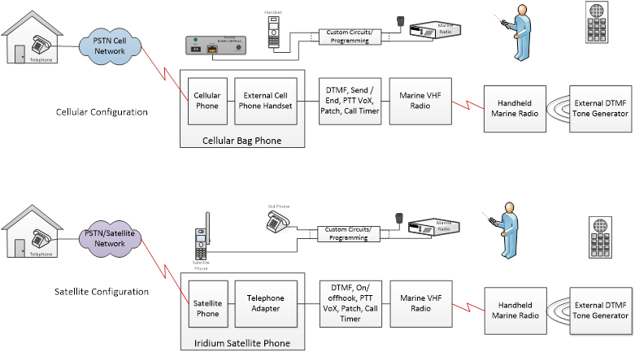

When I was employed by NovAtel (manufacturer of cellular phones and cellular base station equipment) I obtained intimate knowledge of mobile (car/bag) cellular phones and handset integration. Additionally while working at QLC (satellite service provider) we did a number of Mount Everest expeditions where we interfaced radio’s with Tone Remote Adapters to make telephone calls via portable satellite phones. This experience and technical knowledge allowed me to develop a marine radio solution to interface with both cellular and portable satellite phones for use on my sailboat.

I would expect that with some modifications we could customize this design to meet CP Rails requirements once the proof of concept is complete.